Completing the Large Grants Outline Proposal Form
These notes have been written to assist you in completing your application form. They should be read in conjunction with the Community Grant Fund Guidance Notes. If you have any other additional questions or would like to discuss your application before submitting it, please contact catherine.ryan@lowcarbonhub.org or call 01865 246 099.

Your application should be received by 5pm on the closing date. We would prefer to receive electronic applications, which should be sent to info@lowcarbonhub.org. Hard copy applications will be accepted if you cannot submit an electronic version for any reason.

Part A – General Information

Q1. Lead organisation name
This should be the name of the Low Carbon Hub community group that is leading on the application. If more than one is involved, please nominate one lead organisation to co-ordinate the application process.

Joint applications
If you are applying in consortium with other Low Carbon Hub community groups, you need to nominate one organisation to act as the lead. You only need to submit one application form for each project. Should your project be shortlisted, each organisation will need to complete a Grants Finance Form as part of the second stage of application.

If your activity is being carried out in conjunction with any other organisation (other than Low Carbon Hub group network) please give their details in section Part B Question 11. We will not pay grants directly to non-Low Carbon Hub community groups.

Q2 to Q6 Contact details
These will be used to contact you about your application, so please give us the best contact details for correspondence regarding this application.

Part B – About your project

There are no word limits for completing each section, but please use the size of the box as an indication of the level of detail required. Bullet-pointed responses are fine.

1. Project name
Whatever best describes your project.

2. Amount being requested
Low Carbon Hub community groups can apply for one of a small number of grants of up to £5,000. These will be awarded annually, in a competitive process. We welcome joint applications from consortia of two or more Low Carbon Hub community groups. In which case, the maximum funding that can be applied for would be:
- £5,000 per group in the consortia for large community grants, up to the maximum funding available in the fund for that financial year.

There is a total of £10,000 in the grants pot for large grants being awarded this financial year.

If funds sought are towards the cost of a larger project, what is the total cost?
We are interested in understanding if your proposal is part of a larger project. If so, please use the space in Q13 to let us know more about your plans to cover the additional costs.

3. Project start date
Please bear in mind we anticipate it will take us one month to assess and process successful grant applications. If your project is funding, rather than time, specific you can state ‘when funding allows’. We will not provide retrospective funding.

4.Project end date
Project activity should be completed within one year of the grant application deadline.

5. Is this application being made on behalf of a consortium of two or more Low Carbon Hub community groups?
If yes, each group invited to submit detailed applications will have to complete a grant finance form as part of the second stage of the application process.

6. Give a brief description of the activity that will be funded.
Outline the activity that is being proposed, being as specific as possible about timing, duration and scale of activity. If it’s part of a larger piece of work, explain how it fits in. Please note the activity does not have to be directly carried out by your group. When assessing applications, we will take into consideration the extent to which it fit with the core values of our community benefit programme: Community focused; inclusive; collaborative.

The impact your project aims to achieve
The Low Carbon Hub measures its impact in relation to planet, prosperity, people and perception. Use Questions 7 to 12 to demonstrate how your activity might contribute towards these.

Applicants shortlisted for the second application stage will be asked to give further information as to how their project meets our impact guiding principles, namely:

- achieve leverage | - visible | - scalable
- result in tangible outcomes | - replicable | - has lasting impact

You may wish to bear this in mind when beginning to design your initial proposals.

7. PLANET: How will the project contribute towards cutting Oxfordshire’s carbon footprint?
Will the project result in more green energy being generated, or carbon savings?

8. PEOPLE: In which community will the activity take place?
Let us know the name(s) of the Oxfordshire communities where activities will take place or people will benefit.

9. How many people will be involved and in what capacity?
How many people will take part in running the activity and benefit from it? If you are targeting demographic groups, please give details.

10. Tell us about any other organisations that will be involved in the delivery of the activity, and their role.
Use this section to tell us about any other organisations you will be working with, and their role in the activity.

11. PROSPERITY: Will the activity help attract further resources into your community, or result in cost savings?
Does the activity result in creating one off or ongoing income, and how do you intend to use this? Will the activity help reduce energy bills? Does the activity or grant help you secure any matched funding, volunteer time or pro bono services?

12. CO-BENEFITS: Detail any other social, economic, health or environmental benefits you anticipate.
Please tell us about any other benefits your feel your activity may contribute to your community. For example, does it help combat fuel poverty? Bring additional health benefits such as warmer homes or reducing air pollution? Will it benefit community cohesion or help develop skills or expertise within your community?

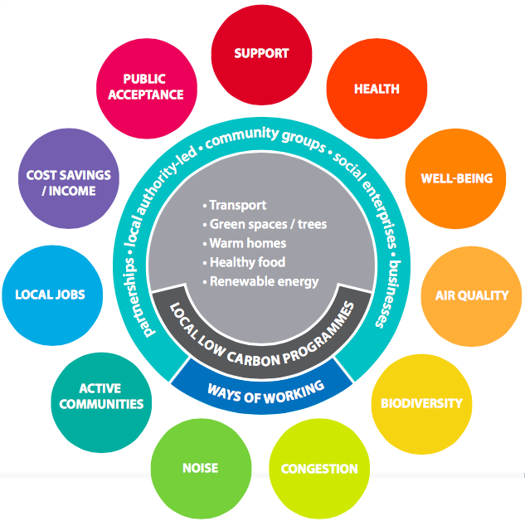
Taken from Building stronger and fairer communities: sharing the co-benefits of local action on climate change. Ruth Mayne, Environmental Change Institute, University of Oxford April 2016. You can read the full report here http://www.agileox.org/building-stronger-and-fairer-communities-sharing-the-co-benefits-of-local-action-on-climate-change/

13. What success measures will you use to evaluate your activity?
You will be asked about the outcome and impact of your activity at the end of the project. Please outline how you plan to evaluate your success in achieving these. A reporting form will be made available at the time grant offers are made, so you can build your monitoring and evaluation into your programme delivery. These reports enable us to be accountable to our stakeholders regarding the way the community benefit income is used.

14. What lasting impact do you hope your project will deliver?
Will it result in a permanent change, or benefit, that will last beyond the duration of the initial project? Is your project replicable or scalable, and if so, what plans do you have to share your learning? Please note we may be able to support you with writing up a case study about your project and sharing details with other low carbon groups.

15. Is there anything else you would like to tell us about your application?
If your application requires additional funding, please let us know how this is to be met.

16. Finally, please let us know of any suggestions you might have to improve our grant application process.
We want this application process to be as simple as possible to enable you to carry out your low carbon work in the community, whilst enabling us to ensure community benefit income is spent in an effective and transparent way. If you have any suggestions as to how this process could be improved, please let us know.

